GitHub Link - <https://github.com/JoelBough/Three_Or_More>

YouTube Link - <https://www.youtube.com/watch?v=hURoylKM4Og>

Features:

Interfaces: Can be used to create multiple variations of one class(e.g. amateur/pro player)

-Occurs whenever I create a new object(Die/Player)

Exception Handling: used to throw an error if something goes wrong or to redirect if there’s an invalid input

Occurs when something doesn’t work in the code that means the game is unable to run

Used try, catch to detect.



Polymorphism: uses overloading to change which method a call goes into based on parameters

-Is there so if the code changes and the sides of the dice change there is an error thrown

Constructor: when each class is called it goes into constructor first to do a task

-Used in Die and Player to roll a dice or set the score of the player to 0.

Encapsulation: keeps information specific to one class within that class and cant be accessed by anything not altering that class

-Used to create variables only altered by the dice classes.

- includes public/private control and abstraction.

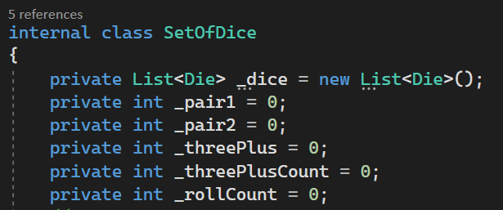

Testing:

Expectation -When given the choice to enter a value to keep, doesn’t throw error when nothing/integer not one of the choices or a letter is entered but asks questions again.

Rolls 4 dice first as all dice are different

Keeps the input dice and rolls the other 4

Input and Output :

Also correctly tallies points for 1, 2, 3, 4 and 5 of a kind.

Expectation -Reaches set end value and askes for play again. When a value not Y or N is entered into play again it doesn’t cause an error but asks for another input.

